September/October 2019 EDITION

DQ GOLF FOR KIDS SAKE RAISED OVER
$25, 000.00!!
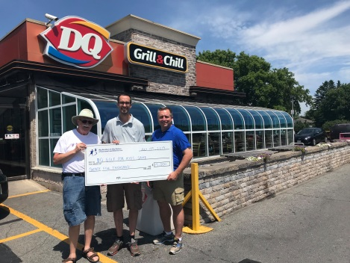
DQ Golf for Kids Sake took place at Cornwall Golf & Country Club on Wed. July 17th. Our 25th annual golf tournament saw over 150 golfers raising over $25,000 for Big Brothers Big Sisters mentoring programs. Thank you to our title sponsor DQ Grill & Chill, and our media sponsor TC Media/Seaway News for your continued support! Thank you to all of our prize donors, teehole sponsors, staff and volunteers for your help in making this year’s tournament so successful!

Sock Sale Success
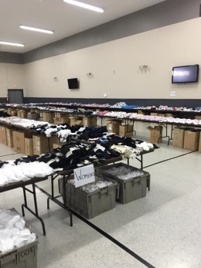
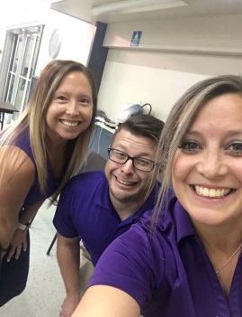
Our 4th Annual Sock sale saw hundreds of customers at Natvitity Hall on August 23rd^{th} -24th and raised $5,000 which goes directly to our 7 mentoring programs. A BIG thank you to all our lovely volunteers, board members and staff for helping out, Ray Eady at Allstate for donating shopping bags, and to Agora Centre for their continued support. Special thanks to Seaway Express, Benson Certified Auto Service, Tim Horton’s, Subway, Pizza Pizza and Leon’s Cornwall!!! This all could not be possible without YOU!

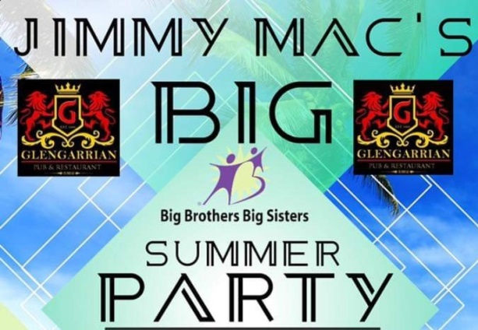

Jimmy Mac’s Big Summer Party
The inaugural Jimmy Mac’s BIG Summer Party was a huge success at the Glengarrian Pub & Restaurant in support of our agency! There were family friendly games, live musical entertainment as well as a BBQ (sponsored by M&M Meat) in the parking lot of the Tudor Centre on August 25th. The day was capped off with a hilarious performance by the Questionable Comedians. More than $4,000 was raised for our mentoring programs thanks to the hard work and support of Dona Cruickshank and Paul Leger (from the Glengarrian). A special thank you to our auction sponsors including Fresh Co., Lowe’s, Akwesasne Mohawk Casino, Upper Canada Mortgage, Cornwall Golf & Country Club, Eight Zero Zero and Dr. Rachel Navaneelan Family & Cosmetic Dentistry. We’re already looking forward to the 2020 version of Jimmy Mac’s BIG Summer Party!

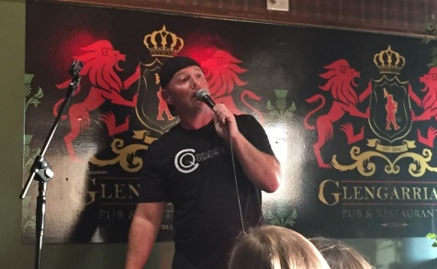
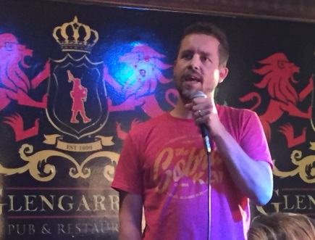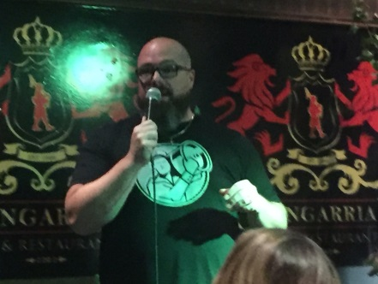

- Save the Date –
Annual Banquet and Awards Night
Saturday, November 9th, 2019 at
The Cornwall Golf and Country Club.

This is a night we celebrate YOU- our volunteers! Join us for an enchanted night to thank you “for making our littles dreams come true.”

Awards will be given out for the following:
Big Brother of the Year ~ Big Sister of the Year Little
Brother of the Year ~ Little Sister of the Year
Honorary Big of the Year ~ BIG Business of the Year
Service Awards for years of service

Two Ways to donate without opening your wallet:

Any used electronics can be donated at the BBBS office. J.Henstock properly recycles and disposes of electronics, which helps reduce waste going to our landfills and also directly helps fund Big Brothers Big Sisters!

If you’re holding a yard sale, cleaning out your closets, moving, or making room for new stuff, please drop off your gently used clothing at Value Village. Clothing donations translate into funds, which help support all 7 of our mentoring programs. Please share the news with friends, co-workers and family members.

United Way will be launching their 2019 Campaign in September. BBBS has been a member agency of the S. D. & G. United Way since 2007. With the help of the community and the United Way, we are able to enhance the lives of more youth and children in need of friendship and guidance. Thank you for supporting the United Way!
September is BBBS MONTH, help us celebrate!
#ImagineBBBS
“Imagine who they will become because of you”
Join the movement:
Be an ambassador for mentoring and changing the lives of youth today!
Why not share a story, refer a friend, spread the word or share our page Donate - Big Brothers Big Sisters of Cornwall and District
Upcoming Events
Hiking
Some of our Bigs and Littles will be heading to Chelsea, QC to venture up the Wolf Hiking Trail. This an 8.9km hike with some pretty amazing views. Littles will be surprised with hiking packs put together by Joe Wilderness on the day of the hike. Spaces are full but if you’d like to sign up on the waitlist contact the office.
WHEN: Saturday, September 21, 2019
WHERE: Chelsea, QC
TIME: 9am-4pm Bus will be leaving from the Aquatic Center
COST: No charge
Please call the office at 613-933-8035 to register

Shoeless Joes
One of our FAVOURITE nights is back!
We have an evening of games planned. We will be meeting at Shoeless Joes for 6:00pm to eat pizza, and donuts and play games.
WHEN: Monday, October 21nd, 2019
WHERE: 812 Pitt Street Unit #42, Cornwall
TIME: 6:00 PM – 8:00 PM
COST: FREE
To sign up please email kelsey.jeaurond@bigbrothersbigsisters.ca or call at 613-933-8035.
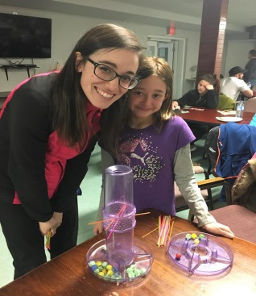
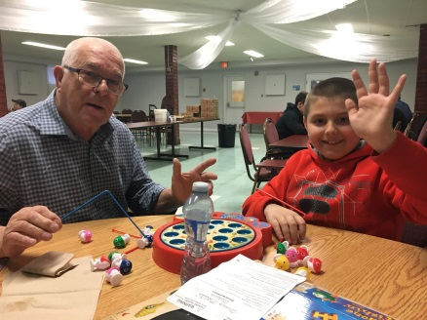
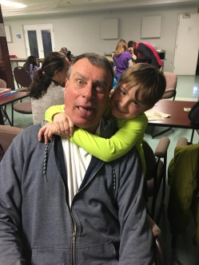

A BIG THANKS
We would like to send a BIG thank you to Dr. Rachel Navaneelan for her very generous donation that allowed us to send some of our Bigs and their Littles to Calypso Waterpark in July. It was a perfect day. Thanks to your generosity our Littles had smiles painted on their faces all day!
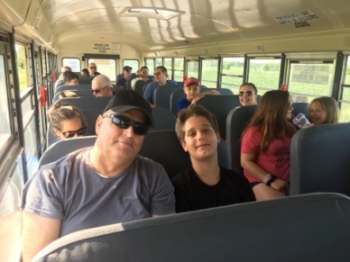
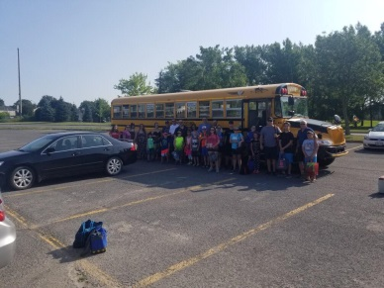
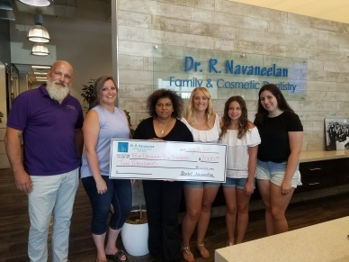

We’d like to give a BIG thank you to Scotiabank for their support in our 2019 DQ Golf for Kid’s Sake this summer. Your support to our programs in very much appreciated and will help support our 7 mentoring programs.
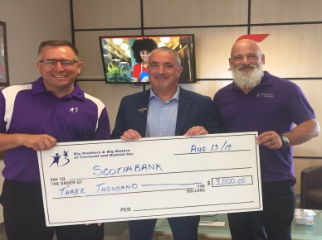

Thanks to Cory from A Big Ride for Littles for donating funds that allowed us to take some of our Littles back to school shopping. Our Littles got to go on a shopping spree at Value Village and Walmart for new clothes and school supplies. Because of you they were able to start the school year off on the right foot. A BIG thank you to you.
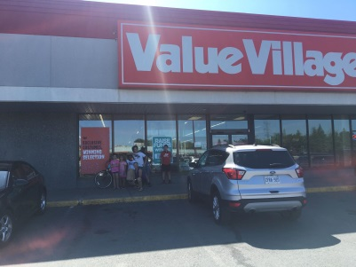
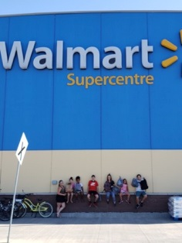

We have had a great summer thanks to local support. Thank you to Tanya Flaro of REMAX for her donation of $2500.00 to help run our 7 mentoring programs. As well as, ParaMED, Shannon and Alisha, Medical Arts pharmacy and all those of you who have donated throughout the summer. Our programs couldn’t run without your support.
Here we have Big Sister Shannon and Little Sister Madison. These two went out on one Big for a Day outing and knew they were a match made in Heaven. They bonded over the fact that both of them were in the process of moving and their love for mini putt! We can’t wait to see what they get up to next!

New Matches

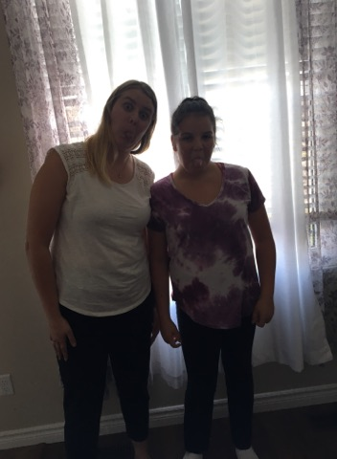

Big Sister Theresa and Little Sister Kaylen hit it off instantly! Their bond and connection apparent from the get go and were laughing, joking and smiling all the way through their match meeting. They cannot wait to see what adventures they are going to get up t throughout their match.

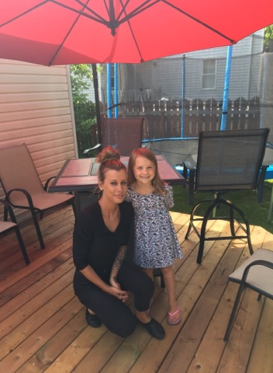

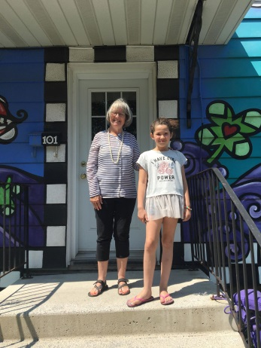
Big Sister Deb and Little Sister Tamya have been off to a great start! They enjoyed their first outing to McDonalds where they got to play in the play place. On one of their outings they collected rocks from the river and painted them. Tamya was a sweetheart and these two can’t wait to create some more amazing memories

Match Anniversaries

October:
Oct. 03/17 Matthieu Richer with Landon
Oct.05/18 Sue Sharpe with Kylie
Oct. 20/09 Bob Carlisle with Hunter
Oct.20/15 Tamara Delage with Taylor
Oct.24/17 Blake Bingley with Hudsyn
Oct 28/14 Carol-Ann Allen with Brigid

September:
Sep.6/18 Shawndra Whaley with Tehya
Sep.9/16 Terry Vandeglind with Dallas
Sep.12/14 Elizabeth Quenville with Emma
Sept.14/17 Dylan Hardy with Jacob

Staff Information

Executive Director- Ron Graham
ronald.graham @bigbrothersbigsisters.ca

Caseworker- Kelsey Jeaurond
kelsey.jeaurond@bigbrothersbigsisters.ca

Program Coordinator- Brittany Hagen
brittany.hagen@bigbrothersbigsisters.ca
Fundraising Coordinator- David Murphy
david.murphy@bigbrothersbigsisters.ca

Office Assistant- Joel Gibeault
Cornwall@bigbrothersbigsisters.ca

* Please note the office will be closed on Monday, September 2nd, 2019 and Monday, October 14th, 2019.

